Alemania

(Detailed class diagram of the system)

Diagrama de Clases del Sistema

V1.0

03/20/2021

Santo Domingo

Republica Dominicana

|  |  |  |  |
| --- | --- | --- | --- |
| **Historia del Documento** | | | |
| **Versión No.** | **Fecha, dd/mm/aaaa** | **Autor(es)** | **Rol** |
| 1.0 | 03/20/2021 | Ronny Melo | Programador, Tester |
|  |  |  |  |
|  |  |  |  |
|  |  |  |  |
|  |  |  |  |
|  |  |  |  |

|  |  |  |
| --- | --- | --- |
| **Responsables** | | |
| **Nombre** | **Rol** | **Contacto** |
| Ronny Melo | Programador, Analista | [ronnyamelo@yahoo.es](mailto:ronnyamelo@yahoo.es) |
| Anthony de Jesus Colon | Programador, Tester |  |
| Luis Mateo | Programador, Tester | Luismateo9594@gmail.com |
|  |  |  |

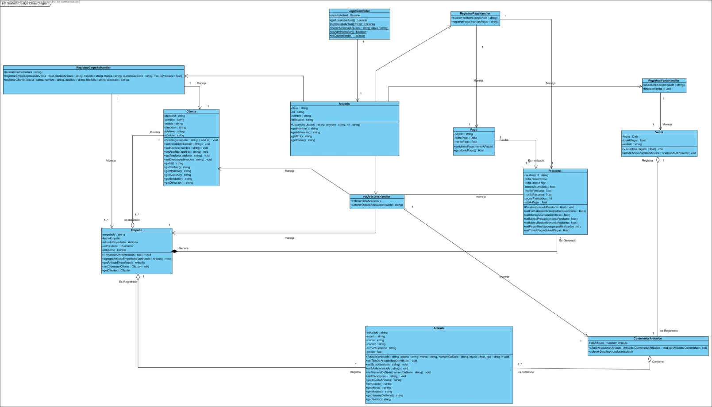Detailed class diagram of the system.